**NAME:** Abenes, Enrico O. **DATE:** June 10, 2023

**SUBJECT & SECTION:** TECHNO 100, INTL 1 **SCHEDULE:** 11: 30 am – 1: 20 pm FSat

**Social Issue**

* **Healthcare**
* Nutritional Education and Awareness – Many individuals lack knowledge about proper nutrition and the importance of balanced diets.
* Personal Health and Well-being – Monitoring calorie intake and macronutrient consumption is crucial for maintaining overall health and well-being.

**NutriTrack: Calorie & Macronutrient Monitor**

A smartphone application that lets users keep track of their caloric intake, keep tabs on how much protein, carbs, and fat they consume, and get tailored suggestions for meals and snacks depending on their dietary requirements. The software will include an intuitive user interface, simple data entry procedures, and clever algorithms to present users with ideas that are pertinent to their needs.

**Protype**

1. 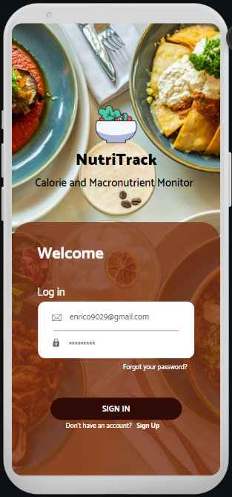**Welcome Home Screen**

* Include a welcome screen with a brief introduction and a call-to-action button to proceed to the main app.

1. 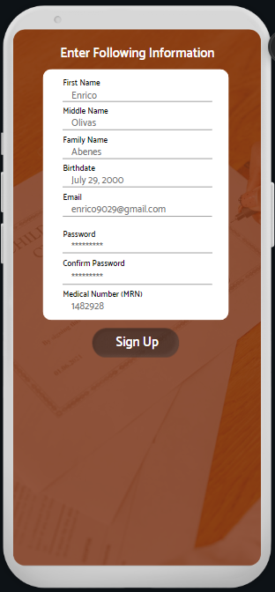**Registration/Sign-Up**

* Design screens for user registration or sign-up.
* Collect necessary information like name, email, password, and any other relevant details for user profiles.

1. 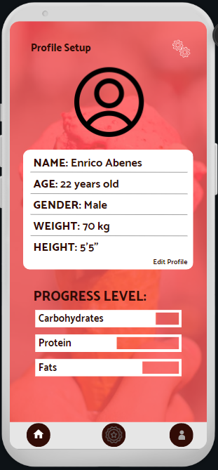**Profile Setup**

* Create screens to set up user profiles with information such as age, gender, weight, height, and activity level.

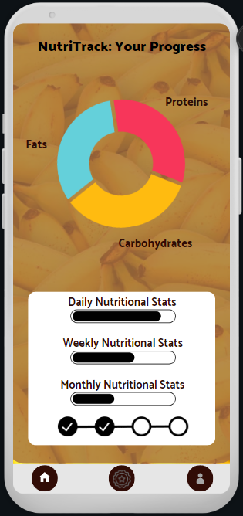

1. **Report and Progress Tracking**

* It presents thorough statistics on the user's daily, weekly, and monthly dietary habits.
* Include graphs or charts to show progress over time, such as intakes or the distribution of macronutrients.

1. **Nutritional Recommendation**

* Design screens to display personalized meal recommendations based on the user's profile and dietary needs.
* 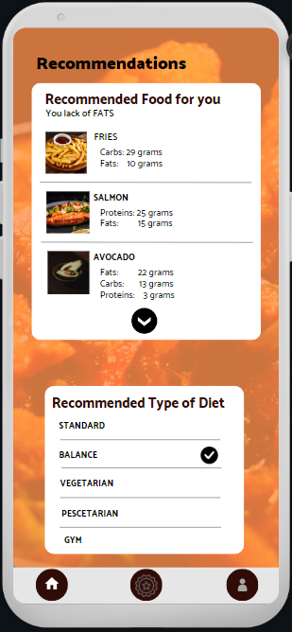Include options for generating recommendations for specific meals or snacks.
* Show alternative meal choices to address macronutrient deficiencies or meet specific dietary restrictions.
* Allow users to specify their diet plans so that the app may suggest the best items to consume.

**Problems that Solve by the NutriTrack Application**

For people who are concerned about their diet and nutrition, NutriTrack: Calorie & Macronutrient Monitor seeks to address the issue of monitoring and managing calorie intake and macronutrient consumption.

* ***Lack of Awareness –*** By providing details on the number of calories, carbohydrates, protein, and fats in various foods, NutriTrack helps users become more aware of this information and make better nutritional decisions.
* ***Difficulty in Tracking Intake –*** The user-friendly design of NutriTrack makes it simple to track and monitor a person's nutritional intake by allowing users to log their food and beverage intake.
* ***Personalized Nutritional Monitoring –*** Users can create profiles on NutriTrack, which offers individualized advice and monitoring based on their particular needs and ensures that they are in line with their individual health goals.
* ***Macronutrient Imbalances –*** In order to encourage a more balanced diet, NutriTrack assists users in tracking their macronutrient distribution and notifies them whether they are falling short of or surpassing the recommended amount.
* ***Lack of Meal Planning Guidance –*** Based on their dietary choices and objectives, NutriTrack provides users with meal recommendations and ideas. Users who struggle with meal planning, particularly when they lack the skills or inspiration to make wholesome meals, can benefit from this function.